Q1. Prove the following series by mathematical induction.

a. ½ +1/6+1/12 +….+1/[n(n+1)] = n/[n+1]

b. 1+4+7 +…. (3n-2) = n(3n1-1)2

|  |  |  |
| --- | --- | --- |
| A | ½ +1/6+1/12 +….+1/[n(n+1)] = n/[n+1] |  |
| B | 1+4+7 +…. (3n-2) = n(3n1-1)/2 |  |

Q2. Convert the following to DFA

1. 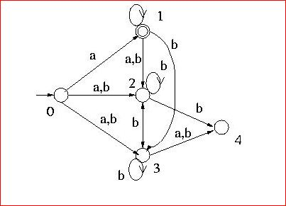

States are named as 0, 1,2,3,4.

1. 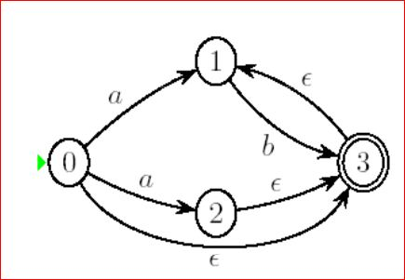

Q3. Reduce the following DFA

i)

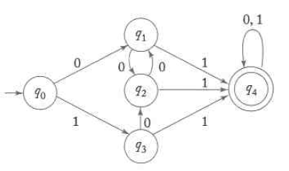

ii)

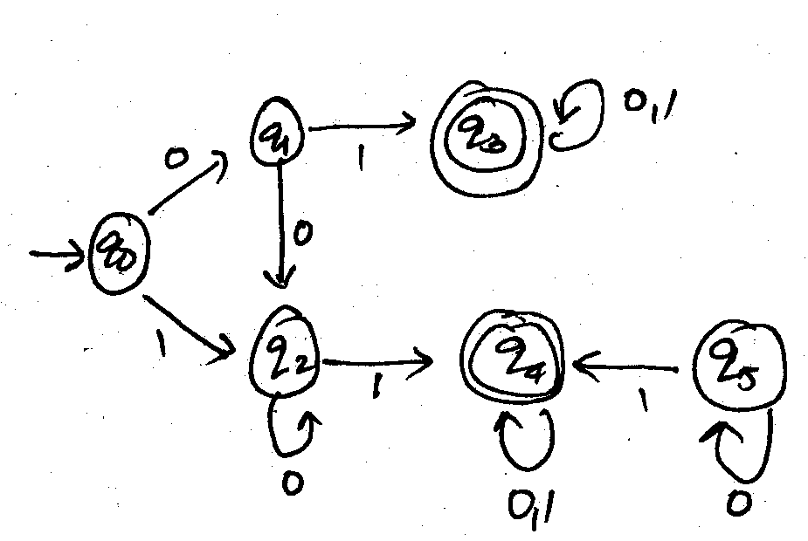

Q4. Find the grammars for the following

     L ={ w :|w| mod   3  ≠  |w| mod 2}

     L  ={wɛ {a+b}*:|na(W)-nb(W)|=1}

Q5.

i. Construct a DFA that accepts a's and b's where 2nd input symbol is 'a' while reading the symbol from RHS.

ii. Construct an NFA that accepts all the strings of a's and b's where the left most 2 symbols and the right most 2 symbols are identical